3/19 trial shuffle and
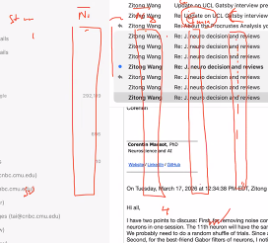
Geometric mean of means: product of two means

If non-correlated, take the average of the noise correlation

Variance and mean of noise correlation for each pair of neurons, you get a two-dimensional plot. Mean as x and variance as y. each point is one neuron pair.

All 50 stimuli or top 5-10 in terms of geometric means
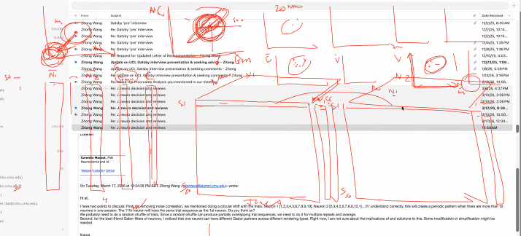

BEFORE and after shuffle mean noise correlation comparison
Distribution of delta nc, combined or separate for within and across session neurons

4/9 Separate neurons by their sessions and then do analysis to show how noise correlation affects the metrics. One datapoint for one session, we got multiple datapoints.

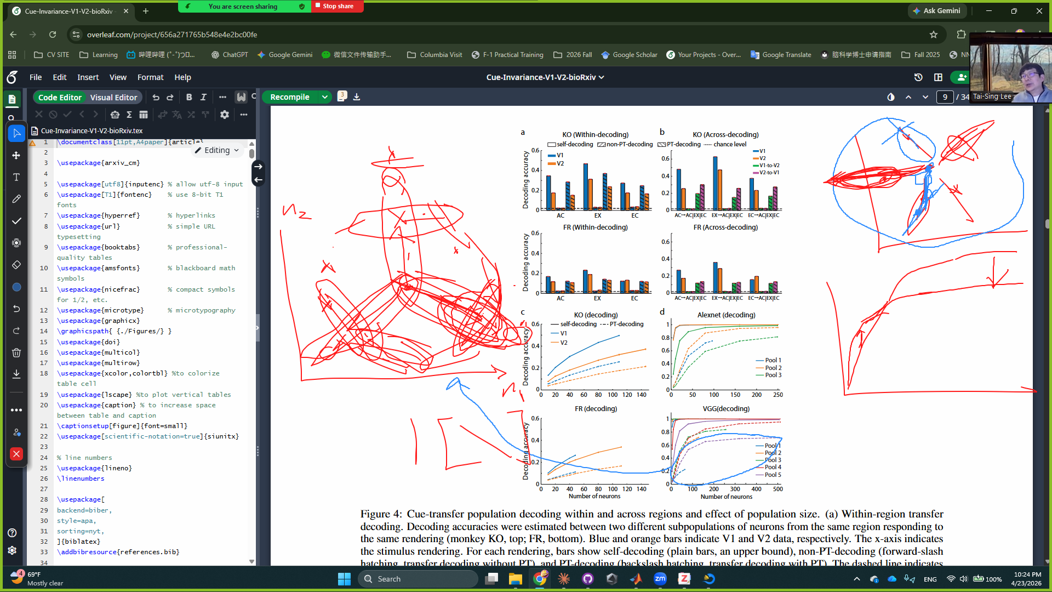

For ANN trial generation, generate trials with two options of stimulus-specific covariance structures:
The reference point can be the centroid of the stimuli or the origin.
Stimulus-specific: trials of each stimulus have their own covariance structure.

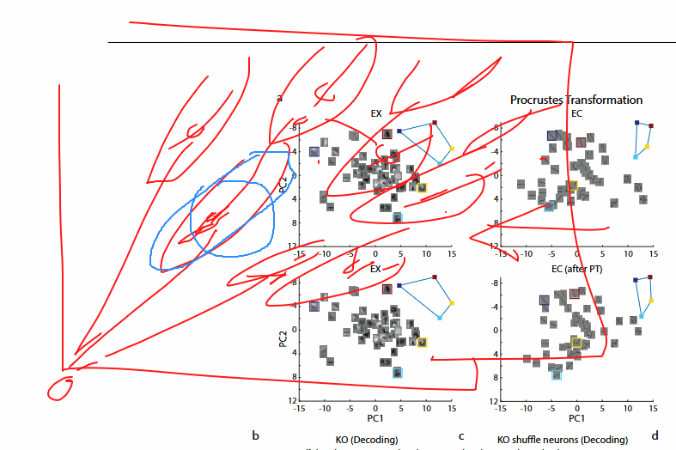
4/30/2026
- Convex hull formed by trials of stims: stimPair wise or the all 50 stims
- Some numbers and tests for the non-affine difference: now the difference is computed. We can also compute delta (A-B) / mean (A & B). Take the average over monkeys and areas?

- Simple geo metrics
&
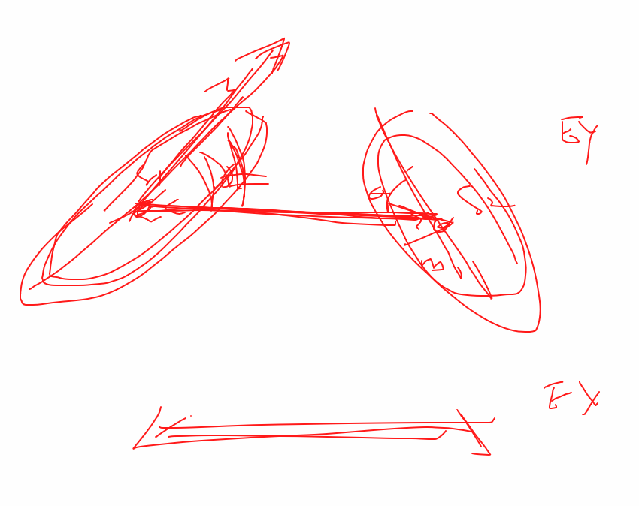
Angles in EX vs. angles in EC: what is the correlation? What is the null?

5/28/2026
1. triplets (4,5 or 50-plets) of stimuli, take the most outward (compared to the centroid or the clouds of other stimuli) trial points, does the geometry of these outliers remain more preserved across renderings?
2. Measure the geometry of angles that correspond to the covariance direction.
3. Compare Gabor and neurons with increasing predictors and report the intrinsic dimensions.

6/11/2026
- Simple geometric metric with or without within-session correlation?
- Angles formed by the First PC axis and the connecting line
- Participation ratio vs. decoding for Gabor and neurons

